武汉纺织大学

Java应用开发课程设计

**基于MyBatis的简单在线考试系统**

**学 院： 数学与计算机学院**

**班 级： 软件工程11801**

**姓 名： 田茁**

**学 号： 1804240710**

**指导老师： 聂刚**

**成 绩：**

**完成日期： 2020年6月20日**

目 录

1 需求分析 1

1.1用户登陆 1

1.2教师用户 1

1.2.1 题库管理 1

1.2.2 考试管理 1

1.2.3 成绩查询 2

1.2.4 成绩统计 2

1.2.5 退出 3

1.3学生用户 1

1.3.1 考试系统 1

2 系统设计 3

2.1用户用例图 3

2.2 ER图 4

2.3 UML类图（Class Diagram） 4

2.4 UML时序图（Sequence Diagram） 6

2.4.1 系统登录 6

2.5 UML活动图（Activity Diagram） 6

2.5.1 登陆 6

2.5.1 考试系统 7

3 系统实现 9

3.1 项目结构 9

3.2 配置文件 9

3.2.1 jdbc.properties文件 9

3.2.2 log4j.properties文件 9

3.2.3 mybatis-config.xml文件 10

3.3 VO类 10

3.4 DAO接口类 11

3.5 接口映射文件xml配置文件 11

3.6 工具包Util 11

3.6.1 MybatisUtils.java 11

3.7 服务层 13

3.8 用户界面Driver.java 14

4 系统测试 14

5 系统总结 14

# 1 需求分析

设计一个简单在线考试系统，根据用户名账号的不同，分别对教师、学生进行服务。教师用户可以对题库进行增加，删除、修改，设置试卷题目的数量，考试开始时间，自动生成试卷，对所有学生的成绩进行查询、统计（最高分，最低分，平均分，各分数段成绩百分比等）。学生用户对试卷进行作答，答题完毕后程序自动完成阅卷，并给出成绩。具体要求如下：

## 1.1用户登陆

当程序运行时，显示“欢迎进入****考试系统，请登陆”，提示用户依次输入用户名及其密码，当用户名及密码不正确时，显示提示信息“用户名或密码不正确，请重新输入”，**用户最多可以尝试3次，若输入3次均不正确，则给出提示信息“最多只能尝试3次”**，退出系统；

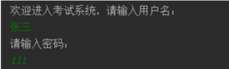

## 1.2教师用户

当用户名及密码正确时，并且核对身份为**教师**后，进入系统主界面，如下：

登录成功！欢迎您，田茁老师

1. 题库管理
2. 考试管理
3. 成绩查询
4. 成绩统计
5. 退出

请选择（1-5）：

如果输入1-5以外的选择，则显示提示信息“输入无效，只能输入1-5”后，返回主界面。

### 1.2.1 题库管理

当教师选择为1时，进入题库管理界面(二级菜单界面)，如下：

进入题库管理模式：

1、增加题目

2、删除题目

3、修改题目

4、查询题目

5、退出

请选择（1-5）：

如果输入1-5以外的选择，则显示提示信息“输入无效，只能输入1-5”后，返回主界面。

1.2.1.1 增加题目

教师在题库管理模式下，输入1时，可对数据库表格增添新的题目，教师需要输入题目题干及答案的格式如下：

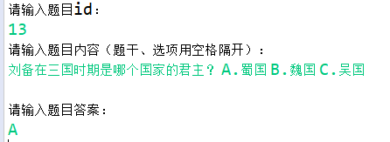

输入题目题干和答案后，系统自动将题目插入数据库的question表中；

1.2.1.2 删除题目

教师在题库管理模式下，输入2时，可对数据库中的题目进行删除，教师需要输入题目id的格式如下：



输入题目id后，系统自动将题目从数据库的question表中删除，并提示“删除成功！”；

1.2.1.3 修改题目

教师在题库管理模式下，输入3时，可对数据库中的题目进行修改，教师需要输入题目id的格式如下：

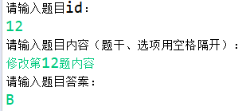

输入题目id后，再输入新的题目内容和答案，系统自动将题目从数据库的question表中修改，并提示“修改成功！”；

1.2.1.4 查询题目

教师在题库管理模式下，输入4时，可从数据库question表中查询题目，教师需要输入题目id的格式，系统将从数据库中查询该id的题目，并显示相关信息，如下：



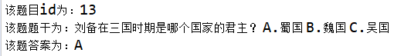

若输入的题目id不存在，则显示“没有该题！”；

1.2.1.5 退出

选择6时，退出题库管理模式，返回主菜单(上一级菜单)。

### 1.2.2 考试管理

当教师选择为2时，进行考试管理，可以修改下次考试试卷的题目数量，如下：



### 1.2.3 成绩查询

当教师选择为3时，可以输入学生姓名，查询学生的成绩，如下：





### 1.2.4 成绩统计

当教师选择为4时，显示学生的最高分，最低分，平均分，各分数段成绩百分比，如下：

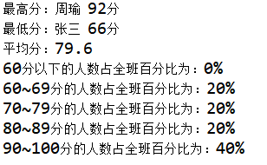

### 1.2.5 退出

选择5时，退出程序。

## 1.3学生用户

当用户名及密码正确时，并且核对身份为学生后，进入考试界面，如下：



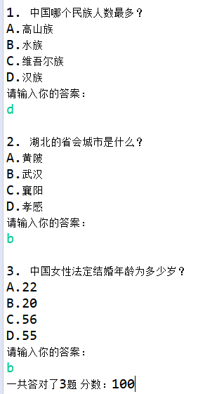

考试结束后自动评分，并且数据记录到数据库

# **2 系统设计**

## 2.1用户用例图

系统分为教师，学生两个角色，各角色的用户用例如下图2-1所示：

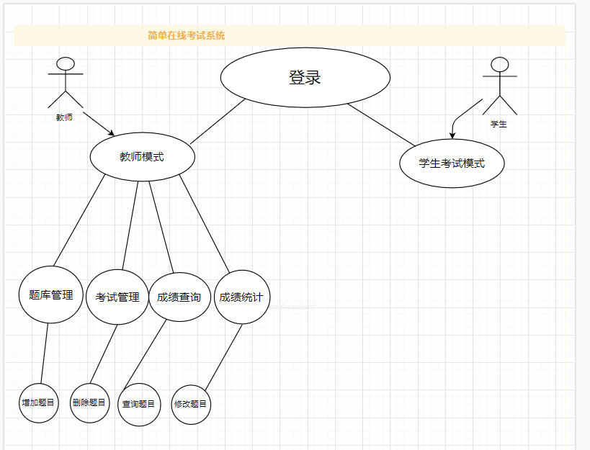

图2-1 用户用例图

## 2.2 ER图

数据库设计4张表，用户表，教师表，学生表，题目表对应的ER图如图3-1所示。

%3CmxGraphModel%3E%3Croot%3E%3CmxCell%20id%3D%220%22%2F%3E%3CmxCell%20id%3D%221%22%20parent%3D%220%22%2F%3E%3Cmysql.table%20entity.table.tableName%3D%22uses%22%20label%3D%22uses%22%20id%3D%222%22%3E%3CmxCell%20style%3D%22swimlane%3BfontStyle%3D0%3BchildLayout%3DstackLayout%3Bhorizontal%3D1%3Bhtml%3D1%3BstartSize%3D26%3BfillColor%3D%23b0e3e6%3BhorizontalStack%3D0%3BresizeParent%3D1%3BresizeParentMax%3D0%3BresizeLast%3D0%3Bcollapsible%3D1%3BmarginBottom%3D0%3BswimlaneFillColor%3D%23ffffff%3Balign%3Dcenter%3BfontSize%3D13%3BstrokeColor%3D%230e8088%3Brounded%3D0%3Bshadow%3D1%3Bcomic%3D0%3Bglass%3D0%3BgradientDirection%3Dsouth%3BgradientColor%3D%23ffffff%3B%22%20vertex%3D%221%22%20connectable%3D%220%22%20parent%3D%221%22%3E%3CmxGeometry%20x%3D%2260%22%20y%3D%2250%22%20width%3D%22310%22%20height%3D%22130%22%20as%3D%22geometry%22%2F%3E%3C%2FmxCell%3E%3C%2Fmysql.table%3E%3Cmysql.column%20entity.column.tableName%3D%22uses%22%20entity.column.name%3D%22userName%22%20entity.column.dataType%3D%22VARCHAR%22%20entity.column.PK%3D%22true%22%20label%3D%22%26lt%3Bimg%20title%3D%26quot%3BPrimary%20Key%26quot%3B%20src%3D%26quot%3Bimg%2Fdb%2Fkey1.png%26quot%3B%20width%3D%26quot%3B16%26quot%3B%20height%3D%26quot%3B16%26quot%3B%20align%3D%26quot%3Btop%26quot%3B%26gt%3B%26amp%3Bnbsp%3B%26lt%3Bfont%20size%3D%26quot%3B1%26quot%3B%20face%3D%26quot%3BTahoma%26quot%3B%26gt%3B%26lt%3Bspan%20style%3D%26quot%3Bfont-size%3A%2013px%26quot%3B%26gt%3B%26lt%3Bb%26gt%3Bid%20int%20primary%20key%26lt%3B%2Fb%26gt%3B%26lt%3B%2Fspan%26gt%3B%26lt%3B%2Ffont%26gt%3B%22%20entity.column.oldName%3D%22id%22%20entity.column.datalen%3D%2220%22%20entity.column.decimals%3D%22%22%20entity.column.autoIncreament%3D%22%22%20entity.column.unsigned%3D%22%22%20entity.column.bin%3D%22%22%20entity.column.ascii%3D%22%22%20entity.column.unicode%3D%22%22%20entity.column.unique%3D%22%22%20entity.column.isNotNull%3D%22NOT%20NULL%22%20entity.column.defaultValue%3D%22%22%20entity.column.comment%3D%22%22%20entity.column.enum%3D%22%22%20entity.column.set%3D%22%22%20entity.column.enumSetValue%3D%22%22%20id%3D%223%22%3E%3CmxCell%20style%3D%22text%3Bhtml%3D1%3BstrokeColor%3Dnone%3BfillColor%3Dnone%3BspacingLeft%3D4%3BspacingRight%3D4%3Boverflow%3Dhidden%3Brotatable%3D0%3BportConstraint%3Deastwest%3BfontSize%3D12%3BverticalAlign%3Dmiddle%3B%22%20vertex%3D%221%22%20parent%3D%222%22%3E%3CmxGeometry%20y%3D%2226%22%20width%3D%22310%22%20height%3D%2226%22%20as%3D%22geometry%22%2F%3E%3C%2FmxCell%3E%3C%2Fmysql.column%3E%3Cmysql.column%20entity.column.tableName%3D%22uses%22%20entity.column.name%3D%22chrName%22%20entity.column.datalen%3D%2220%22%20entity.column.dataType%3D%22VARCHAR%22%20label%3D%22%26lt%3Bimg%20title%3D%26quot%3BPrimary%20Key%26quot%3B%20src%3D%26quot%3Bimages%2Fspacer.gif%26quot%3B%20width%3D%26quot%3B16%26quot%3B%20height%3D%26quot%3B16%26quot%3B%20align%3D%26quot%3Btop%26quot%3B%26gt%3B%26amp%3Bnbsp%3B%26lt%3Bfont%20size%3D%26quot%3B1%26quot%3B%20face%3D%26quot%3BTahoma%26quot%3B%26gt%3B%26lt%3Bspan%20style%3D%26quot%3Bfont-size%3A%2013px%26quot%3B%26gt%3B%26lt%3Bb%26gt%3Bname%20varchar(10)%26lt%3B%2Fb%26gt%3B%26lt%3B%2Fspan%26gt%3B%26lt%3B%2Ffont%26gt%3B%22%20entity.column.oldName%3D%22name%22%20entity.column.decimals%3D%22%22%20entity.column.autoIncreament%3D%22%22%20entity.column.unsigned%3D%22%22%20entity.column.bin%3D%22%22%20entity.column.ascii%3D%22%22%20entity.column.unicode%3D%22%22%20entity.column.PK%3D%22false%22%20entity.column.unique%3D%22%22%20entity.column.isNotNull%3D%22%22%20entity.column.defaultValue%3D%22%22%20entity.column.comment%3D%22%22%20entity.column.enum%3D%22%22%20entity.column.set%3D%22%22%20entity.column.enumSetValue%3D%22%22%20id%3D%224%22%3E%3CmxCell%20style%3D%22text%3Bhtml%3D1%3BstrokeColor%3Dnone%3BfillColor%3Dnone%3BspacingLeft%3D4%3BspacingRight%3D4%3Boverflow%3Dhidden%3Brotatable%3D0%3BportConstraint%3Deastwest%3BfontSize%3D12%3BverticalAlign%3Dmiddle%3B%22%20vertex%3D%221%22%20parent%3D%222%22%3E%3CmxGeometry%20y%3D%2252%22%20width%3D%22310%22%20height%3D%2226%22%20as%3D%22geometry%22%2F%3E%3C%2FmxCell%3E%3C%2Fmysql.column%3E%3Cmysql.column%20entity.column.tableName%3D%22uses%22%20entity.column.name%3D%22password%22%20entity.column.datalen%3D%2250%22%20entity.column.dataType%3D%22VARCHAR%22%20label%3D%22%26lt%3Bimg%20title%3D%26quot%3BPrimary%20Key%26quot%3B%20src%3D%26quot%3Bimages%2Fspacer.gif%26quot%3B%20width%3D%26quot%3B16%26quot%3B%20height%3D%26quot%3B16%26quot%3B%20align%3D%26quot%3Btop%26quot%3B%26gt%3B%26amp%3Bnbsp%3B%26lt%3Bfont%20size%3D%26quot%3B1%26quot%3B%20face%3D%26quot%3BTahoma%26quot%3B%26gt%3B%26lt%3Bspan%20style%3D%26quot%3Bfont-size%3A%2013px%26quot%3B%26gt%3B%26lt%3Bb%26gt%3Bname%20varchar(10)%26lt%3B%2Fb%26gt%3B%26lt%3B%2Fspan%26gt%3B%26lt%3B%2Ffont%26gt%3B%22%20entity.column.oldName%3D%22chrName%22%20entity.column.decimals%3D%22%22%20entity.column.autoIncreament%3D%22%22%20entity.column.unsigned%3D%22%22%20entity.column.bin%3D%22%22%20entity.column.ascii%3D%22%22%20entity.column.unicode%3D%22%22%20entity.column.PK%3D%22false%22%20entity.column.unique%3D%22%22%20entity.column.isNotNull%3D%22%22%20entity.column.defaultValue%3D%22%22%20entity.column.comment%3D%22%E5%AF%86%E7%A0%81%22%20entity.column.enum%3D%22%22%20entity.column.set%3D%22%22%20entity.column.enumSetValue%3D%22%22%20id%3D%225%22%3E%3CmxCell%20style%3D%22text%3Bhtml%3D1%3BstrokeColor%3Dnone%3BfillColor%3Dnone%3BspacingLeft%3D4%3BspacingRight%3D4%3Boverflow%3Dhidden%3Brotatable%3D0%3BportConstraint%3Deastwest%3BfontSize%3D12%3BverticalAlign%3Dmiddle%3B%22%20vertex%3D%221%22%20parent%3D%222%22%3E%3CmxGeometry%20y%3D%2278%22%20width%3D%22310%22%20height%3D%2226%22%20as%3D%22geometry%22%2F%3E%3C%2FmxCell%3E%3C%2Fmysql.column%3E%3Cmysql.column%20entity.column.tableName%3D%22uses%22%20entity.column.name%3D%22role%22%20entity.column.datalen%3D%2220%22%20entity.column.dataType%3D%22VARCHAR%22%20label%3D%22%26lt%3Bimg%20title%3D%26quot%3BPrimary%20Key%26quot%3B%20src%3D%26quot%3Bimages%2Fspacer.gif%26quot%3B%20width%3D%26quot%3B16%26quot%3B%20height%3D%26quot%3B16%26quot%3B%20align%3D%26quot%3Btop%26quot%3B%26gt%3B%26amp%3Bnbsp%3B%26lt%3Bfont%20size%3D%26quot%3B1%26quot%3B%20face%3D%26quot%3BTahoma%26quot%3B%26gt%3B%26lt%3Bspan%20style%3D%26quot%3Bfont-size%3A%2013px%26quot%3B%26gt%3B%26lt%3Bb%26gt%3Bname%20varchar(10)%26lt%3B%2Fb%26gt%3B%26lt%3B%2Fspan%26gt%3B%26lt%3B%2Ffont%26gt%3B%22%20entity.column.oldName%3D%22chrName%22%20entity.column.decimals%3D%22%22%20entity.column.autoIncreament%3D%22%22%20entity.column.unsigned%3D%22%22%20entity.column.bin%3D%22%22%20entity.column.ascii%3D%22%22%20entity.column.unicode%3D%22%22%20entity.column.PK%3D%22false%22%20entity.column.unique%3D%22%22%20entity.column.isNotNull%3D%22%22%20entity.column.defaultValue%3D%22%22%20entity.column.comment%3D%22%E8%A7%92%E8%89%B2%22%20entity.column.enum%3D%22%22%20entity.column.set%3D%22%22%20entity.column.enumSetValue%3D%22%22%20id%3D%226%22%3E%3CmxCell%20style%3D%22text%3Bhtml%3D1%3BstrokeColor%3Dnone%3BfillColor%3Dnone%3BspacingLeft%3D4%3BspacingRight%3D4%3Boverflow%3Dhidden%3Brotatable%3D0%3BportConstraint%3Deastwest%3BfontSize%3D12%3BverticalAlign%3Dmiddle%3B%22%20vertex%3D%221%22%20parent%3D%222%22%3E%3CmxGeometry%20y%3D%22104%22%20width%3D%22310%22%20height%3D%2226%22%20as%3D%22geometry%22%2F%3E%3C%2FmxCell%3E%3C%2Fmysql.column%3E%3Cmysql.table%20entity.table.tableName%3D%22product%22%20label%3D%22product%22%20id%3D%227%22%3E%3CmxCell%20style%3D%22swimlane%3BfontStyle%3D0%3BchildLayout%3DstackLayout%3Bhorizontal%3D1%3Bhtml%3D1%3BstartSize%3D26%3BfillColor%3D%23b0e3e6%3BhorizontalStack%3D0%3BresizeParent%3D1%3BresizeParentMax%3D0%3BresizeLast%3D0%3Bcollapsible%3D1%3BmarginBottom%3D0%3BswimlaneFillColor%3D%23ffffff%3Balign%3Dcenter%3BfontSize%3D13%3BstrokeColor%3D%230e8088%3Brounded%3D0%3Bshadow%3D1%3Bcomic%3D0%3Bglass%3D0%3BgradientDirection%3Dsouth%3BgradientColor%3D%23ffffff%3B%22%20vertex%3D%221%22%20connectable%3D%220%22%20parent%3D%221%22%3E%3CmxGeometry%20x%3D%2260%22%20y%3D%22210%22%20width%3D%22310%22%20height%3D%22130%22%20as%3D%22geometry%22%2F%3E%3C%2FmxCell%3E%3C%2Fmysql.table%3E%3Cmysql.column%20entity.column.tableName%3D%22product%22%20entity.column.name%3D%22barcode%22%20entity.column.dataType%3D%22VARCHAR%22%20entity.column.PK%3D%22true%22%20label%3D%22%26lt%3Bimg%20title%3D%26quot%3BPrimary%20Key%26quot%3B%20src%3D%26quot%3Bimg%2Fdb%2Fkey1.png%26quot%3B%20width%3D%26quot%3B16%26quot%3B%20height%3D%26quot%3B16%26quot%3B%20align%3D%26quot%3Btop%26quot%3B%26gt%3B%26amp%3Bnbsp%3B%26lt%3Bfont%20size%3D%26quot%3B1%26quot%3B%20face%3D%26quot%3BTahoma%26quot%3B%26gt%3B%26lt%3Bspan%20style%3D%26quot%3Bfont-size%3A%2013px%26quot%3B%26gt%3B%26lt%3Bb%26gt%3Bid%20int%20primary%20key%26lt%3B%2Fb%26gt%3B%26lt%3B%2Fspan%26gt%3B%26lt%3B%2Ffont%26gt%3B%22%20entity.column.oldName%3D%22id%22%20entity.column.datalen%3D%2210%22%20entity.column.decimals%3D%22%22%20entity.column.autoIncreament%3D%22%22%20entity.column.unsigned%3D%22%22%20entity.column.bin%3D%22%22%20entity.column.ascii%3D%22%22%20entity.column.unicode%3D%22%22%20entity.column.unique%3D%22%22%20entity.column.isNotNull%3D%22NOT%20NULL%22%20entity.column.defaultValue%3D%22%22%20entity.column.comment%3D%22%22%20entity.column.enum%3D%22%22%20entity.column.set%3D%22%22%20entity.column.enumSetValue%3D%22%22%20id%3D%228%22%3E%3CmxCell%20style%3D%22text%3Bhtml%3D1%3BstrokeColor%3Dnone%3BfillColor%3Dnone%3BspacingLeft%3D4%3BspacingRight%3D4%3Boverflow%3Dhidden%3Brotatable%3D0%3BportConstraint%3Deastwest%3BfontSize%3D12%3BverticalAlign%3Dmiddle%3B%22%20vertex%3D%221%22%20parent%3D%227%22%3E%3CmxGeometry%20y%3D%2226%22%20width%3D%22310%22%20height%3D%2226%22%20as%3D%22geometry%22%2F%3E%3C%2FmxCell%3E%3C%2Fmysql.column%3E%3Cmysql.column%20entity.column.tableName%3D%22product%22%20entity.column.name%3D%22productName%22%20entity.column.datalen%3D%2250%22%20entity.column.dataType%3D%22VARCHAR%22%20label%3D%22%26lt%3Bimg%20title%3D%26quot%3BPrimary%20Key%26quot%3B%20src%3D%26quot%3Bimages%2Fspacer.gif%26quot%3B%20width%3D%26quot%3B16%26quot%3B%20height%3D%26quot%3B16%26quot%3B%20align%3D%26quot%3Btop%26quot%3B%26gt%3B%26amp%3Bnbsp%3B%26lt%3Bfont%20size%3D%26quot%3B1%26quot%3B%20face%3D%26quot%3BTahoma%26quot%3B%26gt%3B%26lt%3Bspan%20style%3D%26quot%3Bfont-size%3A%2013px%26quot%3B%26gt%3B%26lt%3Bb%26gt%3Bname%20varchar(10)%26lt%3B%2Fb%26gt%3B%26lt%3B%2Fspan%26gt%3B%26lt%3B%2Ffont%26gt%3B%22%20entity.column.oldName%3D%22name%22%20entity.column.decimals%3D%22%22%20entity.column.autoIncreament%3D%22%22%20entity.column.unsigned%3D%22%22%20entity.column.bin%3D%22%22%20entity.column.ascii%3D%22%22%20entity.column.unicode%3D%22%22%20entity.column.PK%3D%22false%22%20entity.column.unique%3D%22%22%20entity.column.isNotNull%3D%22%22%20entity.column.defaultValue%3D%22%22%20entity.column.comment%3D%22%22%20entity.column.enum%3D%22%22%20entity.column.set%3D%22%22%20entity.column.enumSetValue%3D%22%22%20id%3D%229%22%3E%3CmxCell%20style%3D%22text%3Bhtml%3D1%3BstrokeColor%3Dnone%3BfillColor%3Dnone%3BspacingLeft%3D4%3BspacingRight%3D4%3Boverflow%3Dhidden%3Brotatable%3D0%3BportConstraint%3Deastwest%3BfontSize%3D12%3BverticalAlign%3Dmiddle%3B%22%20vertex%3D%221%22%20parent%3D%227%22%3E%3CmxGeometry%20y%3D%2252%22%20width%3D%22310%22%20height%3D%2226%22%20as%3D%22geometry%22%2F%3E%3C%2FmxCell%3E%3C%2Fmysql.column%3E%3Cmysql.column%20entity.column.tableName%3D%22product%22%20entity.column.name%3D%22price%22%20entity.column.datalen%3D%229%22%20entity.column.dataType%3D%22DECIMAL%22%20label%3D%22%26lt%3Bimg%20title%3D%26quot%3BPrimary%20Key%26quot%3B%20src%3D%26quot%3Bimages%2Fspacer.gif%26quot%3B%20width%3D%26quot%3B16%26quot%3B%20height%3D%26quot%3B16%26quot%3B%20align%3D%26quot%3Btop%26quot%3B%26gt%3B%26amp%3Bnbsp%3B%26lt%3Bfont%20size%3D%26quot%3B1%26quot%3B%20face%3D%26quot%3BTahoma%26quot%3B%26gt%3B%26lt%3Bspan%20style%3D%26quot%3Bfont-size%3A%2013px%26quot%3B%26gt%3B%26lt%3Bb%26gt%3Bname%20varchar(10)%26lt%3B%2Fb%26gt%3B%26lt%3B%2Fspan%26gt%3B%26lt%3B%2Ffont%26gt%3B%22%20entity.column.oldName%3D%22price%22%20entity.column.decimals%3D%222%22%20entity.column.autoIncreament%3D%22%22%20entity.column.unsigned%3D%22%22%20entity.column.bin%3D%22%22%20entity.column.ascii%3D%22%22%20entity.column.unicode%3D%22%22%20entity.column.PK%3D%22false%22%20entity.column.unique%3D%22%22%20entity.column.isNotNull%3D%22%22%20entity.column.defaultValue%3D%22%22%20entity.column.comment%3D%22%22%20entity.column.enum%3D%22%22%20entity.column.set%3D%22%22%20entity.column.enumSetValue%3D%22%22%20id%3D%2210%22%3E%3CmxCell%20style%3D%22text%3Bhtml%3D1%3BstrokeColor%3Dnone%3BfillColor%3Dnone%3BspacingLeft%3D4%3BspacingRight%3D4%3Boverflow%3Dhidden%3Brotatable%3D0%3BportConstraint%3Deastwest%3BfontSize%3D12%3BverticalAlign%3Dmiddle%3B%22%20vertex%3D%221%22%20parent%3D%227%22%3E%3CmxGeometry%20y%3D%2278%22%20width%3D%22310%22%20height%3D%2226%22%20as%3D%22geometry%22%2F%3E%3C%2FmxCell%3E%3C%2Fmysql.column%3E%3Cmysql.column%20entity.column.tableName%3D%22product%22%20entity.column.name%3D%22supply%22%20entity.column.datalen%3D%2220%22%20entity.column.dataType%3D%22VARCHAR%22%20label%3D%22%26lt%3Bimg%20title%3D%26quot%3BPrimary%20Key%26quot%3B%20src%3D%26quot%3Bimages%2Fspacer.gif%26quot%3B%20width%3D%26quot%3B16%26quot%3B%20height%3D%26quot%3B16%26quot%3B%20align%3D%26quot%3Btop%26quot%3B%26gt%3B%26amp%3Bnbsp%3B%26lt%3Bfont%20size%3D%26quot%3B1%26quot%3B%20face%3D%26quot%3BTahoma%26quot%3B%26gt%3B%26lt%3Bspan%20style%3D%26quot%3Bfont-size%3A%2013px%26quot%3B%26gt%3B%26lt%3Bb%26gt%3Bname%20varchar(10)%26lt%3B%2Fb%26gt%3B%26lt%3B%2Fspan%26gt%3B%26lt%3B%2Ffont%26gt%3B%22%20entity.column.oldName%3D%22price%22%20entity.column.decimals%3D%22%22%20entity.column.autoIncreament%3D%22%22%20entity.column.unsigned%3D%22%22%20entity.column.bin%3D%22%22%20entity.column.ascii%3D%22%22%20entity.column.unicode%3D%22%22%20entity.column.PK%3D%22false%22%20entity.column.unique%3D%22%22%20entity.column.isNotNull%3D%22%22%20entity.column.defaultValue%3D%22%22%20entity.column.comment%3D%22%22%20entity.column.enum%3D%22%22%20entity.column.set%3D%22%22%20entity.column.enumSetValue%3D%22%22%20id%3D%2211%22%3E%3CmxCell%20style%3D%22text%3Bhtml%3D1%3BstrokeColor%3Dnone%3BfillColor%3Dnone%3BspacingLeft%3D4%3BspacingRight%3D4%3Boverflow%3Dhidden%3Brotatable%3D0%3BportConstraint%3Deastwest%3BfontSize%3D12%3BverticalAlign%3Dmiddle%3B%22%20vertex%3D%221%22%20parent%3D%227%22%3E%3CmxGeometry%20y%3D%22104%22%20width%3D%22310%22%20height%3D%2226%22%20as%3D%22geometry%22%2F%3E%3C%2FmxCell%3E%3C%2Fmysql.column%3E%3Cmysql.table%20entity.table.tableName%3D%22saleDetail%22%20label%3D%22saleDetail%22%20id%3D%2212%22%3E%3CmxCell%20style%3D%22swimlane%3BfontStyle%3D0%3BchildLayout%3DstackLayout%3Bhorizontal%3D1%3Bhtml%3D1%3BstartSize%3D26%3BfillColor%3D%23b0e3e6%3BhorizontalStack%3D0%3BresizeParent%3D1%3BresizeParentMax%3D0%3BresizeLast%3D0%3Bcollapsible%3D1%3BmarginBottom%3D0%3BswimlaneFillColor%3D%23ffffff%3Balign%3Dcenter%3BfontSize%3D13%3BstrokeColor%3D%230e8088%3Brounded%3D0%3Bshadow%3D1%3Bcomic%3D0%3Bglass%3D0%3BgradientDirection%3Dsouth%3BgradientColor%3D%23ffffff%3B%22%20vertex%3D%221%22%20connectable%3D%220%22%20parent%3D%221%22%3E%3CmxGeometry%20x%3D%22480%22%20y%3D%2280%22%20width%3D%22280%22%20height%3D%22208%22%20as%3D%22geometry%22%2F%3E%3C%2FmxCell%3E%3C%2Fmysql.table%3E%3Cmysql.column%20entity.column.tableName%3D%22saleDetail%22%20entity.column.name%3D%22lsh%22%20entity.column.dataType%3D%22VARCHAR%22%20entity.column.PK%3D%22true%22%20label%3D%22%26lt%3Bimg%20title%3D%26quot%3BPrimary%20Key%26quot%3B%20src%3D%26quot%3Bimg%2Fdb%2Fkey1.png%26quot%3B%20width%3D%26quot%3B16%26quot%3B%20height%3D%26quot%3B16%26quot%3B%20align%3D%26quot%3Btop%26quot%3B%26gt%3B%26amp%3Bnbsp%3B%26lt%3Bfont%20size%3D%26quot%3B1%26quot%3B%20face%3D%26quot%3BTahoma%26quot%3B%26gt%3B%26lt%3Bspan%20style%3D%26quot%3Bfont-size%3A%2013px%26quot%3B%26gt%3B%26lt%3Bb%26gt%3Bid%20int%20primary%20key%26lt%3B%2Fb%26gt%3B%26lt%3B%2Fspan%26gt%3B%26lt%3B%2Ffont%26gt%3B%22%20entity.column.oldName%3D%22id%22%20entity.column.datalen%3D%2220%22%20entity.column.decimals%3D%22%22%20entity.column.autoIncreament%3D%22%22%20entity.column.unsigned%3D%22%22%20entity.column.bin%3D%22%22%20entity.column.ascii%3D%22%22%20entity.column.unicode%3D%22%22%20entity.column.unique%3D%22%22%20entity.column.isNotNull%3D%22NOT%20NULL%22%20entity.column.defaultValue%3D%22%22%20entity.column.comment%3D%22%22%20entity.column.enum%3D%22%22%20entity.column.set%3D%22%22%20entity.column.enumSetValue%3D%22%22%20id%3D%2213%22%3E%3CmxCell%20style%3D%22text%3Bhtml%3D1%3BstrokeColor%3Dnone%3BfillColor%3Dnone%3BspacingLeft%3D4%3BspacingRight%3D4%3Boverflow%3Dhidden%3Brotatable%3D0%3BportConstraint%3Deastwest%3BfontSize%3D12%3BverticalAlign%3Dmiddle%3B%22%20vertex%3D%221%22%20parent%3D%2212%22%3E%3CmxGeometry%20y%3D%2226%22%20width%3D%22280%22%20height%3D%2226%22%20as%3D%22geometry%22%2F%3E%3C%2FmxCell%3E%3C%2Fmysql.column%3E%3Cmysql.column%20entity.column.tableName%3D%22saleDetail%22%20entity.column.name%3D%22barcode%22%20entity.column.datalen%3D%2210%22%20entity.column.dataType%3D%22VARCHAR%22%20label%3D%22%26lt%3Bimg%20title%3D%26quot%3BPrimary%20Key%26quot%3B%20src%3D%26quot%3Bimages%2Fspacer.gif%26quot%3B%20width%3D%26quot%3B16%26quot%3B%20height%3D%26quot%3B16%26quot%3B%20align%3D%26quot%3Btop%26quot%3B%26gt%3B%26amp%3Bnbsp%3B%26lt%3Bfont%20size%3D%26quot%3B1%26quot%3B%20face%3D%26quot%3BTahoma%26quot%3B%26gt%3B%26lt%3Bspan%20style%3D%26quot%3Bfont-size%3A%2013px%26quot%3B%26gt%3B%26lt%3Bb%26gt%3Bname%20varchar(10)%26lt%3B%2Fb%26gt%3B%26lt%3B%2Fspan%26gt%3B%26lt%3B%2Ffont%26gt%3B%22%20entity.column.oldName%3D%22barcode%22%20entity.column.decimals%3D%22%22%20entity.column.autoIncreament%3D%22%22%20entity.column.unsigned%3D%22%22%20entity.column.bin%3D%22%22%20entity.column.ascii%3D%22%22%20entity.column.unicode%3D%22%22%20entity.column.PK%3D%22false%22%20entity.column.unique%3D%22%22%20entity.column.isNotNull%3D%22%22%20entity.column.defaultValue%3D%22%22%20entity.column.comment%3D%22%22%20entity.column.enum%3D%22%22%20entity.column.set%3D%22%22%20entity.column.enumSetValue%3D%22%22%20id%3D%2214%22%3E%3CmxCell%20style%3D%22text%3Bhtml%3D1%3BstrokeColor%3Dnone%3BfillColor%3Dnone%3BspacingLeft%3D4%3BspacingRight%3D4%3Boverflow%3Dhidden%3Brotatable%3D0%3BportConstraint%3Deastwest%3BfontSize%3D12%3BverticalAlign%3Dmiddle%3B%22%20vertex%3D%221%22%20parent%3D%2212%22%3E%3CmxGeometry%20y%3D%2252%22%20width%3D%22280%22%20height%3D%2226%22%20as%3D%22geometry%22%2F%3E%3C%2FmxCell%3E%3C%2Fmysql.column%3E%3Cmysql.column%20entity.column.tableName%3D%22saleDetail%22%20entity.column.name%3D%22productName%22%20entity.column.datalen%3D%2250%22%20entity.column.dataType%3D%22VARCHAR%22%20label%3D%22%26lt%3Bimg%20title%3D%26quot%3BPrimary%20Key%26quot%3B%20src%3D%26quot%3Bimages%2Fspacer.gif%26quot%3B%20width%3D%26quot%3B16%26quot%3B%20height%3D%26quot%3B16%26quot%3B%20align%3D%26quot%3Btop%26quot%3B%26gt%3B%26amp%3Bnbsp%3B%26lt%3Bfont%20size%3D%26quot%3B1%26quot%3B%20face%3D%26quot%3BTahoma%26quot%3B%26gt%3B%26lt%3Bspan%20style%3D%26quot%3Bfont-size%3A%2013px%26quot%3B%26gt%3B%26lt%3Bb%26gt%3Bname%20varchar(10)%26lt%3B%2Fb%26gt%3B%26lt%3B%2Fspan%26gt%3B%26lt%3B%2Ffont%26gt%3B%22%20entity.column.oldName%3D%22productName%22%20entity.column.decimals%3D%22%22%20entity.column.autoIncreament%3D%22%22%20entity.column.unsigned%3D%22%22%20entity.column.bin%3D%22%22%20entity.column.ascii%3D%22%22%20entity.column.unicode%3D%22%22%20entity.column.PK%3D%22false%22%20entity.column.unique%3D%22%22%20entity.column.isNotNull%3D%22%22%20entity.column.defaultValue%3D%22%22%20entity.column.comment%3D%22%22%20entity.column.enum%3D%22%22%20entity.column.set%3D%22%22%20entity.column.enumSetValue%3D%22%22%20id%3D%2215%22%3E%3CmxCell%20style%3D%22text%3Bhtml%3D1%3BstrokeColor%3Dnone%3BfillColor%3Dnone%3BspacingLeft%3D4%3BspacingRight%3D4%3Boverflow%3Dhidden%3Brotatable%3D0%3BportConstraint%3Deastwest%3BfontSize%3D12%3BverticalAlign%3Dmiddle%3B%22%20vertex%3D%221%22%20parent%3D%2212%22%3E%3CmxGeometry%20y%3D%2278%22%20width%3D%22280%22%20height%3D%2226%22%20as%3D%22geometry%22%2F%3E%3C%2FmxCell%3E%3C%2Fmysql.column%3E%3Cmysql.column%20entity.column.tableName%3D%22saleDetail%22%20entity.column.name%3D%22price%22%20entity.column.datalen%3D%229%22%20entity.column.dataType%3D%22DECIMAL%22%20label%3D%22%26lt%3Bimg%20title%3D%26quot%3BPrimary%20Key%26quot%3B%20src%3D%26quot%3Bimages%2Fspacer.gif%26quot%3B%20width%3D%26quot%3B16%26quot%3B%20height%3D%26quot%3B16%26quot%3B%20align%3D%26quot%3Btop%26quot%3B%26gt%3B%26amp%3Bnbsp%3B%26lt%3Bfont%20size%3D%26quot%3B1%26quot%3B%20face%3D%26quot%3BTahoma%26quot%3B%26gt%3B%26lt%3Bspan%20style%3D%26quot%3Bfont-size%3A%2013px%26quot%3B%26gt%3B%26lt%3Bb%26gt%3Bname%20varchar(10)%26lt%3B%2Fb%26gt%3B%26lt%3B%2Fspan%26gt%3B%26lt%3B%2Ffont%26gt%3B%22%20entity.column.oldName%3D%22productName%22%20entity.column.decimals%3D%222%22%20entity.column.autoIncreament%3D%22%22%20entity.column.unsigned%3D%22%22%20entity.column.bin%3D%22%22%20entity.column.ascii%3D%22%22%20entity.column.unicode%3D%22%22%20entity.column.PK%3D%22false%22%20entity.column.unique%3D%22%22%20entity.column.isNotNull%3D%22%22%20entity.column.defaultValue%3D%22%22%20entity.column.comment%3D%22%22%20entity.column.enum%3D%22%22%20entity.column.set%3D%22%22%20entity.column.enumSetValue%3D%22%22%20id%3D%2216%22%3E%3CmxCell%20style%3D%22text%3Bhtml%3D1%3BstrokeColor%3Dnone%3BfillColor%3Dnone%3BspacingLeft%3D4%3BspacingRight%3D4%3Boverflow%3Dhidden%3Brotatable%3D0%3BportConstraint%3Deastwest%3BfontSize%3D12%3BverticalAlign%3Dmiddle%3B%22%20vertex%3D%221%22%20parent%3D%2212%22%3E%3CmxGeometry%20y%3D%22104%22%20width%3D%22280%22%20height%3D%2226%22%20as%3D%22geometry%22%2F%3E%3C%2FmxCell%3E%3C%2Fmysql.column%3E%3Cmysql.column%20entity.column.tableName%3D%22saleDetail%22%20entity.column.name%3D%22count%22%20entity.column.datalen%3D%229%22%20entity.column.dataType%3D%22INT%22%20label%3D%22%26lt%3Bimg%20title%3D%26quot%3BPrimary%20Key%26quot%3B%20src%3D%26quot%3Bimages%2Fspacer.gif%26quot%3B%20width%3D%26quot%3B16%26quot%3B%20height%3D%26quot%3B16%26quot%3B%20align%3D%26quot%3Btop%26quot%3B%26gt%3B%26amp%3Bnbsp%3B%26lt%3Bfont%20size%3D%26quot%3B1%26quot%3B%20face%3D%26quot%3BTahoma%26quot%3B%26gt%3B%26lt%3Bspan%20style%3D%26quot%3Bfont-size%3A%2013px%26quot%3B%26gt%3B%26lt%3Bb%26gt%3Bname%20varchar(10)%26lt%3B%2Fb%26gt%3B%26lt%3B%2Fspan%26gt%3B%26lt%3B%2Ffont%26gt%3B%22%20entity.column.oldName%3D%22price%22%20entity.column.decimals%3D%22%22%20entity.column.autoIncreament%3D%22%22%20entity.column.unsigned%3D%22%22%20entity.column.bin%3D%22%22%20entity.column.ascii%3D%22%22%20entity.column.unicode%3D%22%22%20entity.column.PK%3D%22false%22%20entity.column.unique%3D%22%22%20entity.column.isNotNull%3D%22%22%20entity.column.defaultValue%3D%22%22%20entity.column.comment%3D%22%22%20entity.column.enum%3D%22%22%20entity.column.set%3D%22%22%20entity.column.enumSetValue%3D%22%22%20id%3D%2217%22%3E%3CmxCell%20style%3D%22text%3Bhtml%3D1%3BstrokeColor%3Dnone%3BfillColor%3Dnone%3BspacingLeft%3D4%3BspacingRight%3D4%3Boverflow%3Dhidden%3Brotatable%3D0%3BportConstraint%3Deastwest%3BfontSize%3D12%3BverticalAlign%3Dmiddle%3B%22%20vertex%3D%221%22%20parent%3D%2212%22%3E%3CmxGeometry%20y%3D%22130%22%20width%3D%22280%22%20height%3D%2226%22%20as%3D%22geometry%22%2F%3E%3C%2FmxCell%3E%3C%2Fmysql.column%3E%3Cmysql.column%20entity.column.tableName%3D%22saleDetail%22%20entity.column.name%3D%22operator%22%20entity.column.datalen%3D%2220%22%20entity.column.dataType%3D%22VARCHAR%22%20label%3D%22%26lt%3Bimg%20title%3D%26quot%3BPrimary%20Key%26quot%3B%20src%3D%26quot%3Bimages%2Fspacer.gif%26quot%3B%20width%3D%26quot%3B16%26quot%3B%20height%3D%26quot%3B16%26quot%3B%20align%3D%26quot%3Btop%26quot%3B%26gt%3B%26amp%3Bnbsp%3B%26lt%3Bfont%20size%3D%26quot%3B1%26quot%3B%20face%3D%26quot%3BTahoma%26quot%3B%26gt%3B%26lt%3Bspan%20style%3D%26quot%3Bfont-size%3A%2013px%26quot%3B%26gt%3B%26lt%3Bb%26gt%3Bname%20varchar(10)%26lt%3B%2Fb%26gt%3B%26lt%3B%2Fspan%26gt%3B%26lt%3B%2Ffont%26gt%3B%22%20entity.column.oldName%3D%22count%22%20entity.column.decimals%3D%22%22%20entity.column.autoIncreament%3D%22%22%20entity.column.unsigned%3D%22%22%20entity.column.bin%3D%22%22%20entity.column.ascii%3D%22%22%20entity.column.unicode%3D%22%22%20entity.column.PK%3D%22false%22%20entity.column.unique%3D%22%22%20entity.column.isNotNull%3D%22%22%20entity.column.defaultValue%3D%22%22%20entity.column.comment%3D%22%22%20entity.column.enum%3D%22%22%20entity.column.set%3D%22%22%20entity.column.enumSetValue%3D%22%22%20id%3D%2218%22%3E%3CmxCell%20style%3D%22text%3Bhtml%3D1%3BstrokeColor%3Dnone%3BfillColor%3Dnone%3BspacingLeft%3D4%3BspacingRight%3D4%3Boverflow%3Dhidden%3Brotatable%3D0%3BportConstraint%3Deastwest%3BfontSize%3D12%3BverticalAlign%3Dmiddle%3B%22%20vertex%3D%221%22%20parent%3D%2212%22%3E%3CmxGeometry%20y%3D%22156%22%20width%3D%22280%22%20height%3D%2226%22%20as%3D%22geometry%22%2F%3E%3C%2FmxCell%3E%3C%2Fmysql.column%3E%3Cmysql.column%20entity.column.tableName%3D%22saleDetail%22%20entity.column.name%3D%22saleTime%22%20entity.column.datalen%3D%22%22%20entity.column.dataType%3D%22DATETIME%22%20label%3D%22%26lt%3Bimg%20title%3D%26quot%3BPrimary%20Key%26quot%3B%20src%3D%26quot%3Bimages%2Fspacer.gif%26quot%3B%20width%3D%26quot%3B16%26quot%3B%20height%3D%26quot%3B16%26quot%3B%20align%3D%26quot%3Btop%26quot%3B%26gt%3B%26amp%3Bnbsp%3B%26lt%3Bfont%20size%3D%26quot%3B1%26quot%3B%20face%3D%26quot%3BTahoma%26quot%3B%26gt%3B%26lt%3Bspan%20style%3D%26quot%3Bfont-size%3A%2013px%26quot%3B%26gt%3B%26lt%3Bb%26gt%3Bname%20varchar(10)%26lt%3B%2Fb%26gt%3B%26lt%3B%2Fspan%26gt%3B%26lt%3B%2Ffont%26gt%3B%22%20entity.column.oldName%3D%22count%22%20entity.column.decimals%3D%22%22%20entity.column.autoIncreament%3D%22%22%20entity.column.unsigned%3D%22%22%20entity.column.bin%3D%22%22%20entity.column.ascii%3D%22%22%20entity.column.unicode%3D%22%22%20entity.column.PK%3D%22false%22%20entity.column.unique%3D%22%22%20entity.column.isNotNull%3D%22%22%20entity.column.defaultValue%3D%22%22%20entity.column.comment%3D%22%22%20entity.column.enum%3D%22%22%20entity.column.set%3D%22%22%20entity.column.enumSetValue%3D%22%22%20id%3D%2219%22%3E%3CmxCell%20style%3D%22text%3Bhtml%3D1%3BstrokeColor%3Dnone%3BfillColor%3Dnone%3BspacingLeft%3D4%3BspacingRight%3D4%3Boverflow%3Dhidden%3Brotatable%3D0%3BportConstraint%3Deastwest%3BfontSize%3D12%3BverticalAlign%3Dmiddle%3B%22%20vertex%3D%221%22%20parent%3D%2212%22%3E%3CmxGeometry%20y%3D%22182%22%20width%3D%22280%22%20height%3D%2226%22%20as%3D%22geometry%22%2F%3E%3C%2FmxCell%3E%3C%2Fmysql.column%3E%3CmxCell%20id%3D%2220%22%20value%3D%221..n%22%20style%3D%22edgeStyle%3DentityRelationEdgeStyle%3BfontSize%3D12%3Bhtml%3D1%3BendArrow%3DERoneToMany%3BstrokeWidth%3D2%3BstrokeColor%3D%236c8ebf%3BexitX%3D1%3BexitY%3D0.25%3BentryX%3D0%3BentryY%3D0.5%3B%22%20edge%3D%221%22%20source%3D%224%22%20target%3D%2214%22%20parent%3D%221%22%3E%3CmxGeometry%20relative%3D%221%22%20as%3D%22geometry%22%2F%3E%3C%2FmxCell%3E%3CmxCell%20id%3D%2221%22%20value%3D%221..n%22%20style%3D%22edgeStyle%3DentityRelationEdgeStyle%3BfontSize%3D12%3Bhtml%3D1%3BendArrow%3DERoneToMany%3BstrokeWidth%3D2%3BstrokeColor%3D%236c8ebf%3BexitX%3D1%3BexitY%3D0.5%3BentryX%3D0%3BentryY%3D0.5%3B%22%20edge%3D%221%22%20source%3D%228%22%20target%3D%2216%22%20parent%3D%221%22%3E%3CmxGeometry%20relative%3D%221%22%20as%3D%22geometry%22%2F%3E%3C%2FmxCell%3E%3C%2Froot%3E%3C%2FmxGraphModel%3E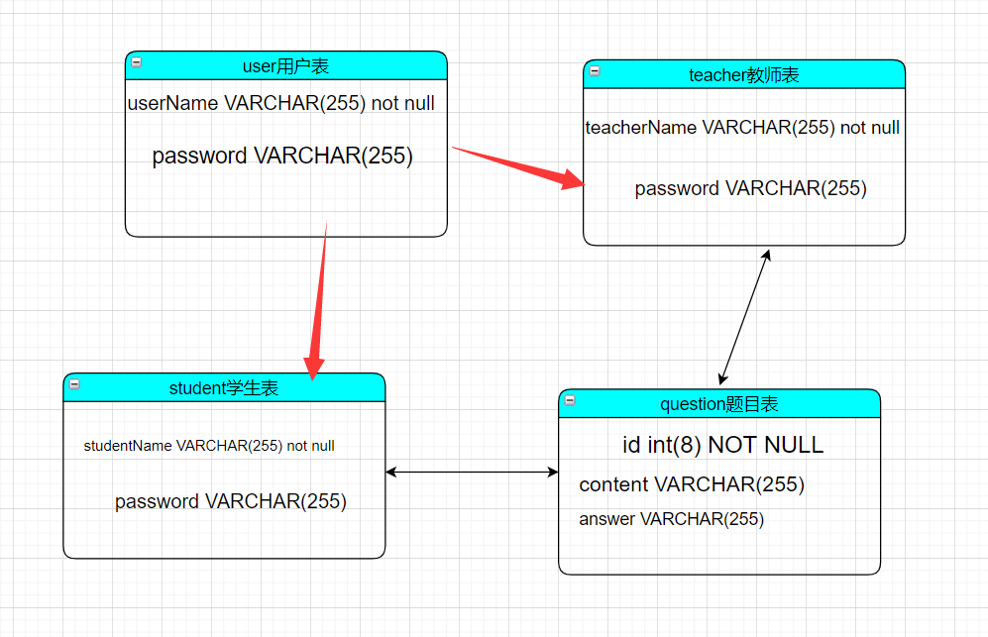

图3-1 数据库ER图

## 2.3 UML类图（Class Diagram）

对于User功能模块，共设计如下4个类。

* VO实体类User：与数据库结构进行映射的类。主要由属性，setter, getter方法组成，VO类中的属性与表中的字段相对应，每一个VO类的对象都表示表中的每一条记录
* DAO接口IUserDAO：主要定义操作的接口，定义一系列数据库的原子性操作，例如增删改查（通常称为CRUD）等。
* Mapper实现类UserMapper：同过mybatis框架，用xml配置文件实现DAO接口的真实实现类，主要完成具体数据库操作。
* 业务逻辑实现类UserService：对于数据层的原子操作进行整合。实现user的所有业务功能。

各类的结构及类之间的关系如图2-5所示：

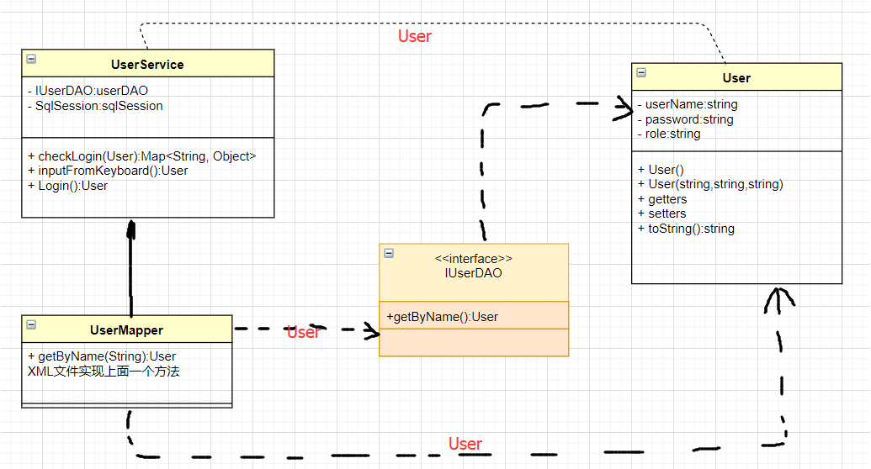

对于教师功能模块，共设计如下4个类。

* VO实体类Teacher：与数据库结构进行映射的类。主要由属性，setter, getter方法组成，VO类中的属性与表中的字段相对应，每一个VO类的对象都表示表中的每一条记录
* DAO接口ITeacherDAO：主要定义操作的接口，定义一系列数据库的原子性操作，例如增删改查（通常称为CRUD）等。
* Mapper实现类TeacherMapper：同过mybatis框架，用xml配置文件实现DAO接口的真实实现类，主要完成具体数据库操作。
* 业务逻辑实现类TeacherService：对于数据层的原子操作进行整合。实现teacher的所有业务功能。

各类的结构及类之间的关系如图2-5所示：

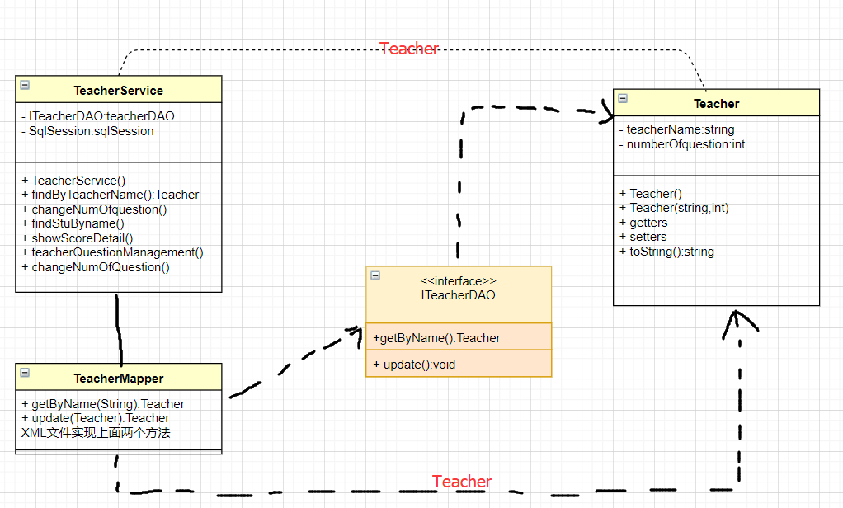

对于学生功能模块，共设计如下4个类。

* VO实体类Student：与数据库结构进行映射的类。主要由属性，setter, getter方法组成，VO类中的属性与表中的字段相对应，每一个VO类的对象都表示表中的每一条记录
* DAO接口IStudentDAO：主要定义操作的接口，定义一系列数据库的原子性操作，例如增删改查（通常称为CRUD）等。
* Mapper实现类StudentMapper：同过mybatis框架，用xml配置文件实现DAO接口的真实实现类，主要完成具体数据库操作。
* 业务逻辑实现类StudentService：对于数据层的原子操作进行整合。实现student的所有业务功能。

各类的结构及类之间的关系如图2-5所示：

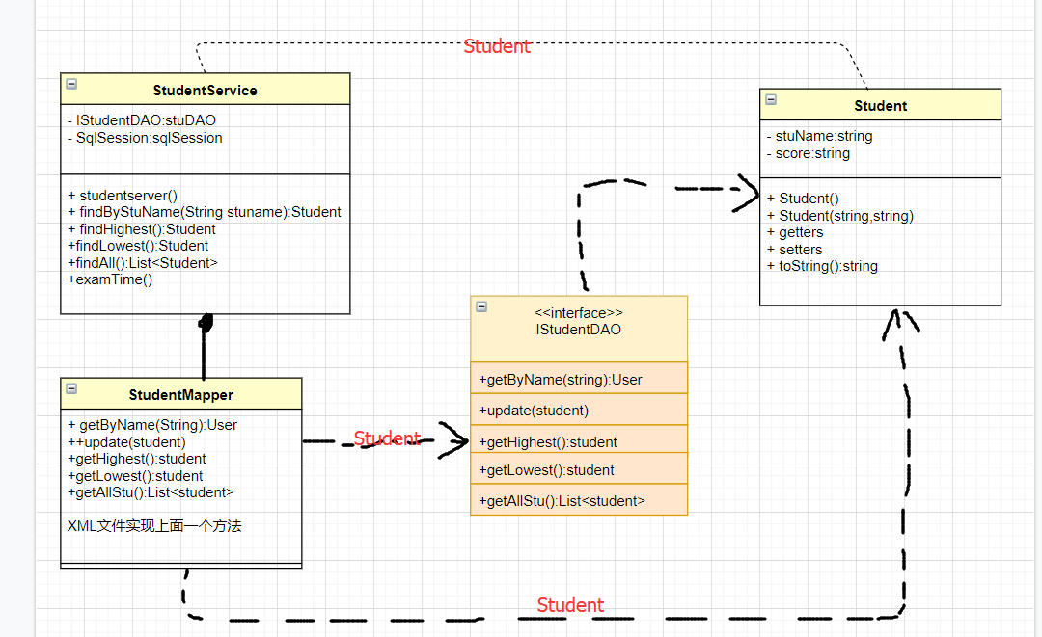

对于question功能模块，共设计如下4个类。

* VO实体类Question：与数据库结构进行映射的类。主要由属性，setter, getter方法组成，VO类中的属性与表中的字段相对应，每一个VO类的对象都表示表中的每一条记录
* DAO接口IQuestionDAO：主要定义操作的接口，定义一系列数据库的原子性操作，例如增删改查（通常称为CRUD）等。
* Mapper实现类QuestionMapper：同过mybatis框架，用xml配置文件实现DAO接口的真实实现类，主要完成具体数据库操作。
* 业务逻辑实现类QuestionService：对于数据层的原子操作进行整合。实现Question的所有业务功能。

各类的结构及类之间的关系如图2-5所示：

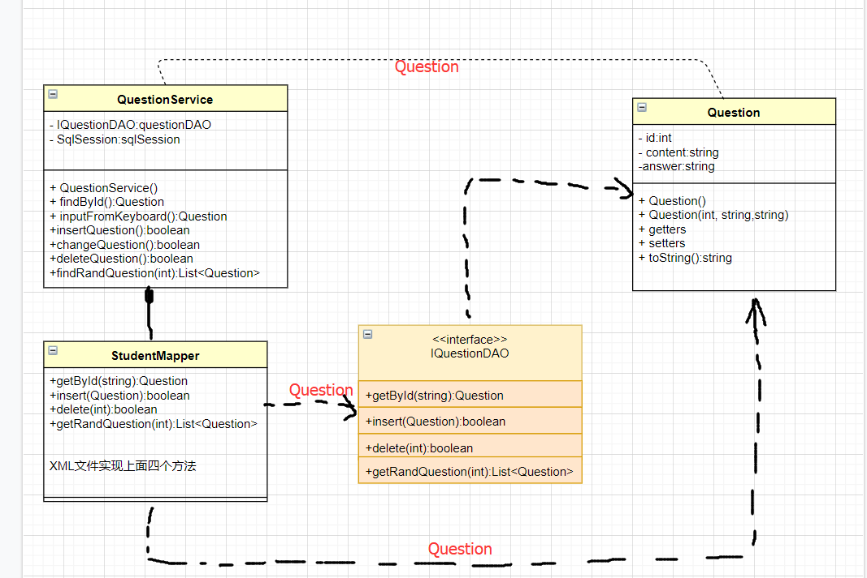

图2-5 用户功能类图

## 2.4 UML时序图（Sequence Diagram）

### 2.4.1 系统登录

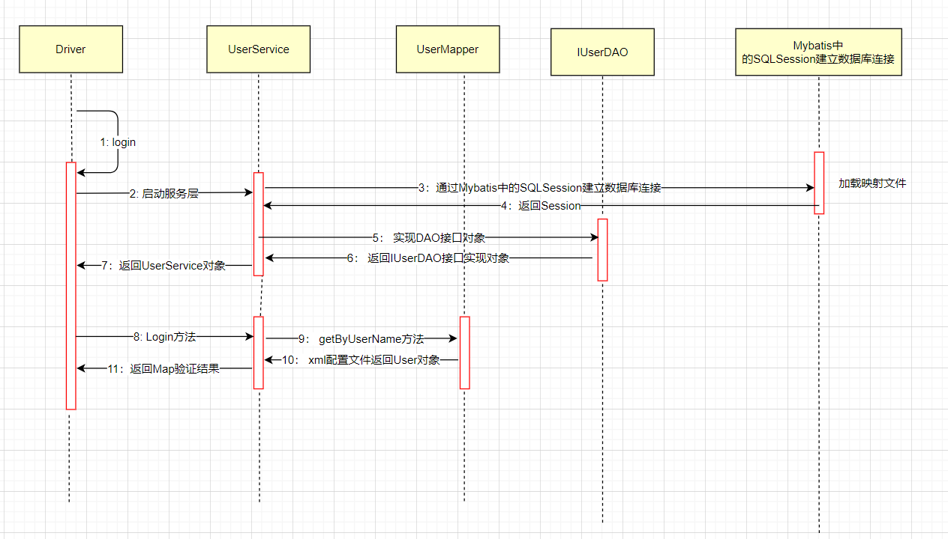

## 2.5 UML活动图（Activity Diagram）

### 2.5.1 登陆

登录操作需要验证用户名，密码，只有当用户名和密码同时存在即用户存在的情况下才能成功登录系统，否则会提示错误信息，具体流程如图2-6所示。

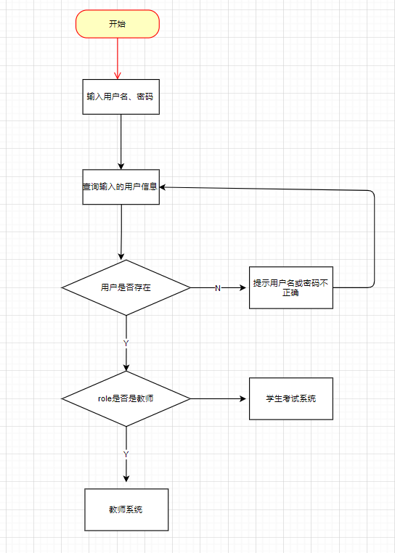

图2-2 登录流程图

### 2.5.2 考试系统

当user的role是student类型时，进入学生的考试系统模式，先读取考试题目的numOfQuestion.txt文件取得考试题目数量，再根据题目数量随机出卷。考试系统的活动图如图2-5所示。

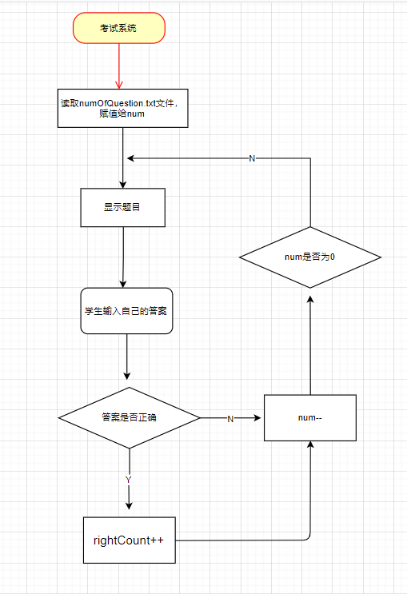

# **3 系统实现**

## 3.1 项目结构

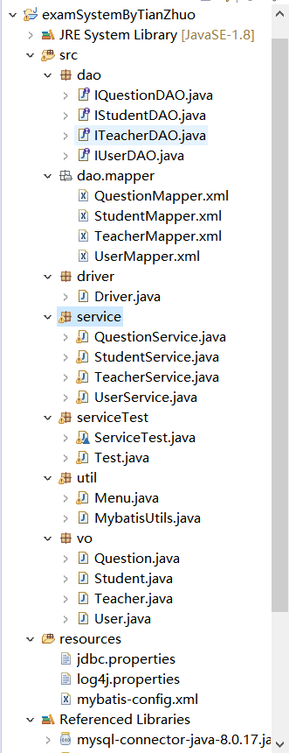

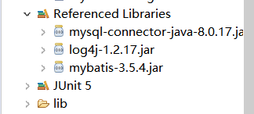

## 3.2 配置文件

在项目下新建Folder，名为resources，再点击右键build path设置为use as source folder

### 3.2.1 jdbc.properties文件

该配置文件主要是以文件形式保存数据库的驱动类名称，连接数据库的URL地址，访问数据库的用户名及对应的密码，程序运行时会读取该文件相关信息，避免硬编码，当相关信息发生变化时，只需修改配置文件而不用修改源代码，增加程序的可扩展型。

DBDRIVER=com.mysql.cj.jdbc.Driver

DBURL=jdbc:mysql://127.0.0.1:3306/examsystem?useUnicode=true&characterEncoding=UTF-8&serverTimezone=UTC

DBUSER=root

PASSWORD=123456

### 3.2.2 log4j.properties文件

描述该文件作用，并对里面的配置进行解释

log4j.rootLogger=DEBUG, stdout

log4j.appender.stdout=org.apache.log4j.ConsoleAppender

log4j.appender.stdout.layout=org.apache.log4j.PatternLayout

log4j.appender.stdout.layout.ConversionPattern=%5p [%t] - %m%n

### 3.2.3 mybatis-config.xml文件

描述该文件作用，并对里面的配置进行解释

<?xml version="1.0" encoding="UTF-8"?>

<!DOCTYPE configuration

PUBLIC "-//mybatis.org//DTD Config 3.0//EN"

"http://mybatis.org/dtd/mybatis-3-config.dtd">

<!-- 根标签 -->

<configuration>

<!-- 指定 资源文件 -->

<properties resource="jdbc.properties"></properties>

<!-- 指定 MyBatis 所用日志的具体实现，未指定时将自动查找-->

<settings>

<setting name="logImpl" value="LOG4J" />

</settings>

<!-- 环境，可以配置多个，default：指定采用哪个环境 -->

<environments default="test">

<!-- id：唯一标识 -->

<environment id="test">

<!-- 事务管理器，JDBC类型的事务管理器 -->

<transactionManager type="JDBC" />

<!-- 数据源，池类型的数据源 -->

<dataSource type="POOLED">

<property name="driver" value="${DBDRIVER}" />

<property name="url" value="${DBURL}" />

<property name="username" value="${DBUSER}" />

<property name="password" value="${PASSWORD}" />

</dataSource>

</environment>

</environments>

<!-- 配置mapper映射文件 -->

<mappers>

<mapper resource="dao/mapper/UserMapper.xml" />

<mapper resource="dao/mapper/TeacherMapper.xml" />

<mapper resource="dao/mapper/StudentMapper.xml" />

<mapper resource="dao/mapper/QuestionMapper.xml" />

</mappers>

</configuration>

## 3.3 VO类

## **3.3.1 User.java**

**public** **class** User {

**private** String userName;

**private** String password;

**private** String role;

//构造方法、getter,setter，toString方法,自行补充

}

## **3.3.2 Teacher.java**

**public** **class** User {

**private** String teacherName;

**private** int numOfquestion;

//构造方法、getter,setter，toString方法,自行补充

}

## **3.3.3 Student.java**

**public** **class** User {

**private** String stuName;

**private** String score;

//构造方法、getter,setter，toString方法,自行补充

}

## **3.3.1 Question.java**

**public** **class** Question{

**private** int **id;**

**private** String **content;**

**private** String **answer;**

//构造方法、getter,setter，toString方法,自行补充

}

## 3.4 DAO接口类

**3.4.1 IUserDAO.java**

**public** **interface** IUserDAO {

// 根据userName找user

**public** User getByName(String userName);

}

**3.4.2 ITeacherDAO.java**

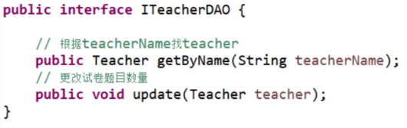

**3.4.3 IStudentDAO.java**

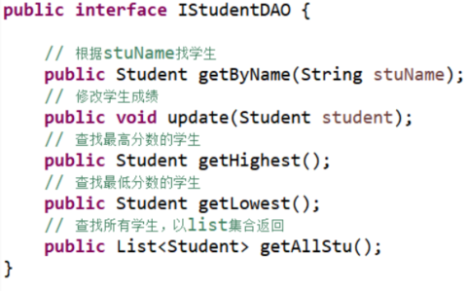

**3.4.4 IQuestionDAO.java**

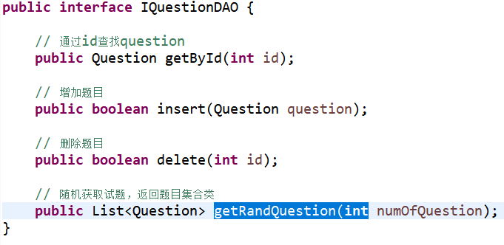

## 3.5 接口映射文件UserMapper.xml

**3.5.1 UserMapper.xml**

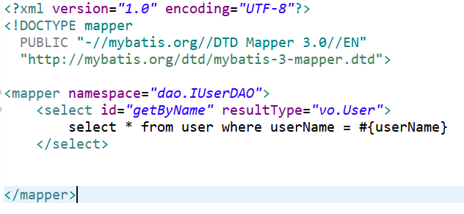

**3.5.2 TeacherMapper.xml**

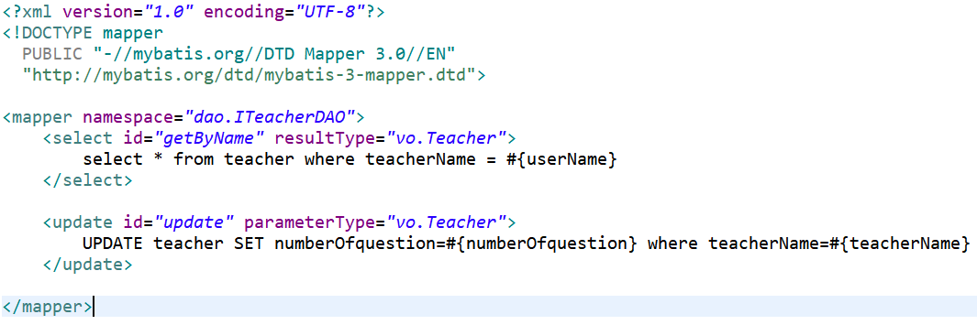

**3.5.3 StudentMapper.xml**

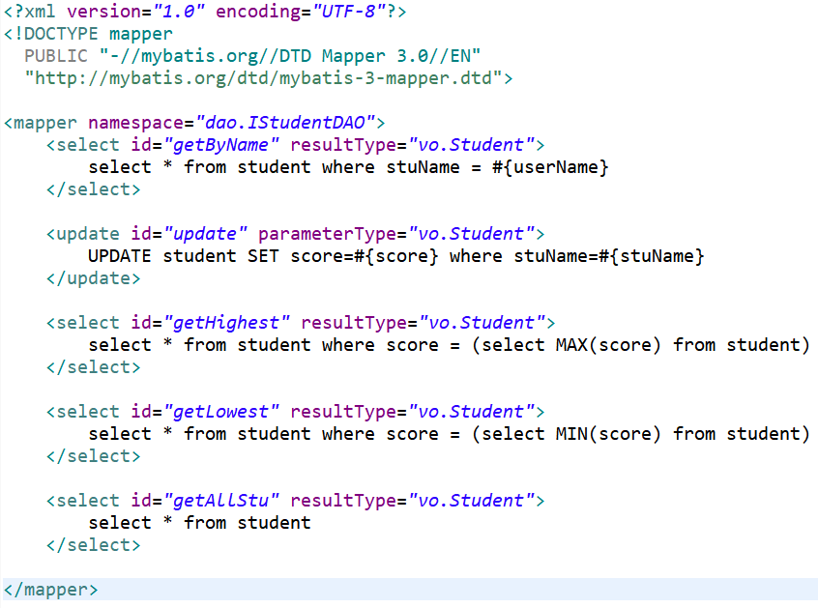

**3.5.4 QuestionMapper.xml**

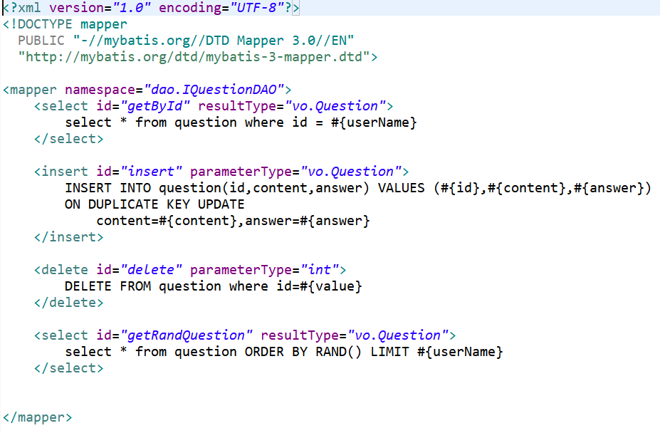

## 3.6 工具包Util

### 3.6.1 MybatisUtils.java

描述该文件作用，并对里面的关键代码进行解释

/**

* 为服务层提供sqlSession对象

*/

**public** **class** MybatisUtils {

**private** **static** SqlSessionFactory *sqlSessionFactory*;

**public** MybatisUtils() {

**super**();

}

/*

* SqlSessionFactory一旦被创建,应该在应用执行期间都存在.在应用运行期间不要重复创建多次

*/

**static** {

String resourse = "mybatis-config.xml";

**try** {

InputStream inputStream = Resources.*getResourceAsStream*(resourse);

*sqlSessionFactory* = **new** SqlSessionFactoryBuilder().build(inputStream);

} **catch** (IOException e) {

e.printStackTrace();

}

}

**public** **static** SqlSession getSqlSession() {

// 如果不设置参数或者参数为false就是手动提交事务，参数设置为true就是自动提交事务

SqlSession sqlSession = *sqlSessionFactory*.openSession();

**return** sqlSession;

}

}

## 3.7 服务层

## **3.7.1 UserService.java**

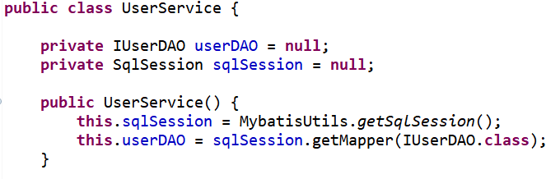

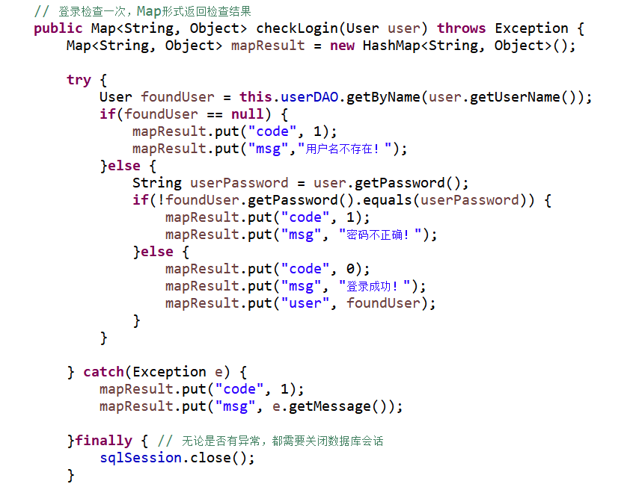

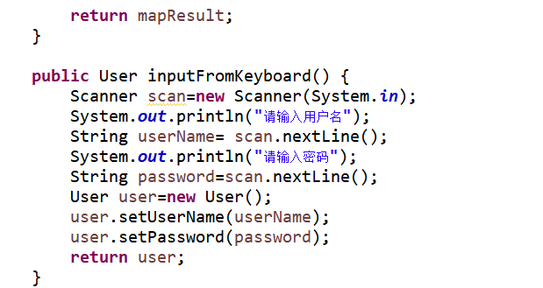

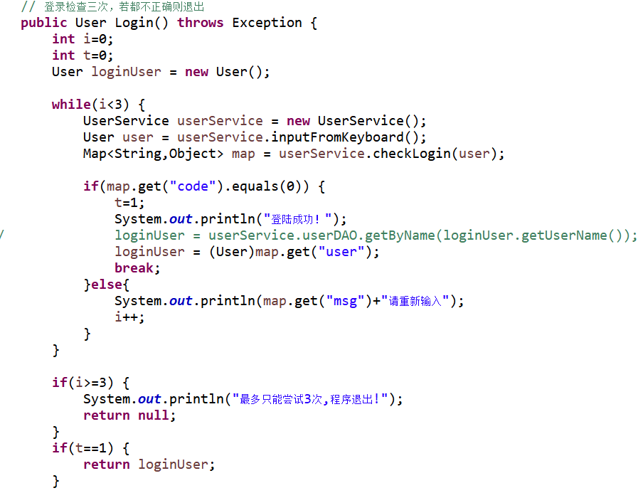

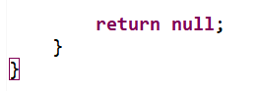

## **3.7.2 TeacherService.java**

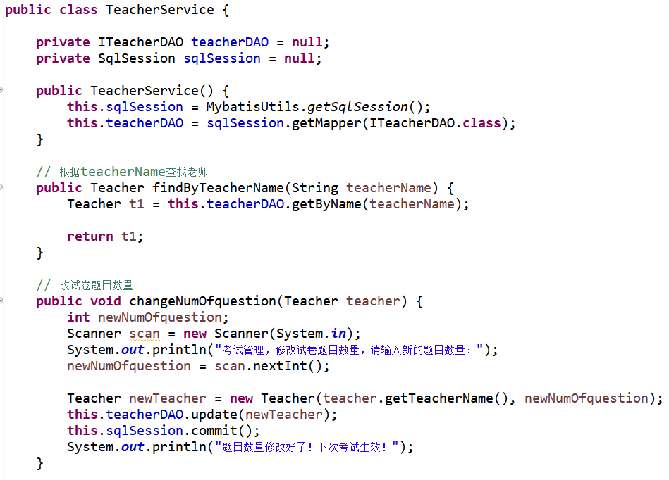

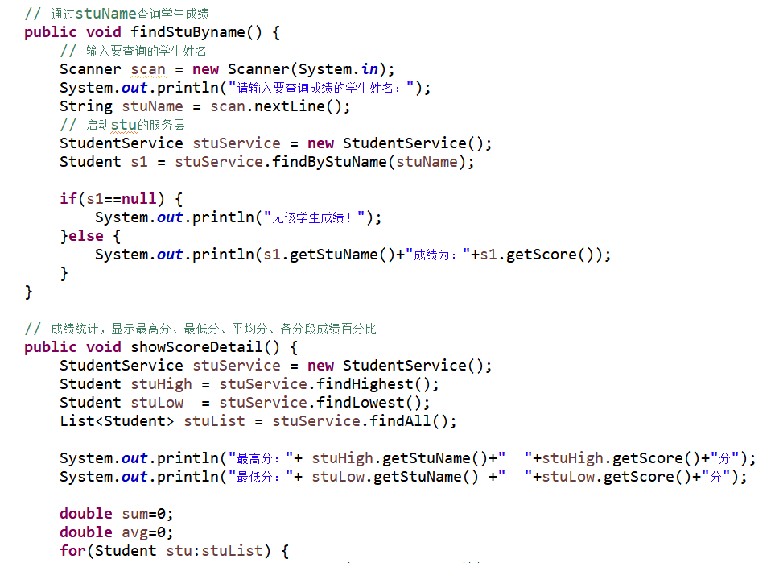

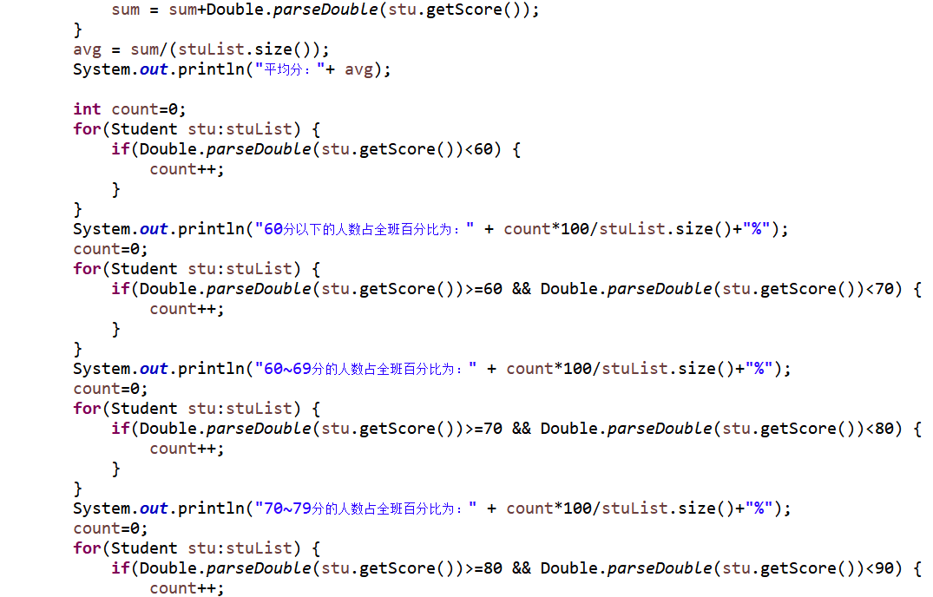

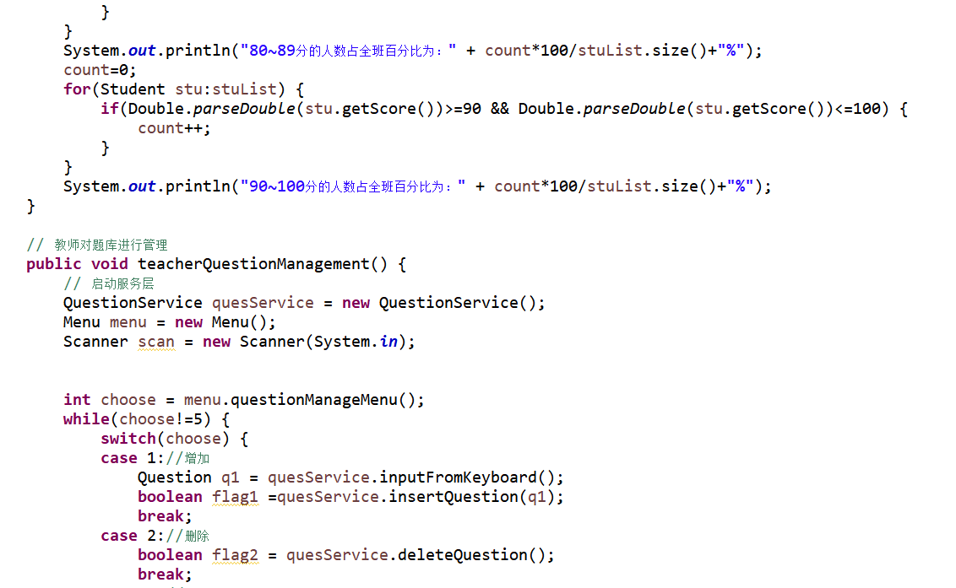

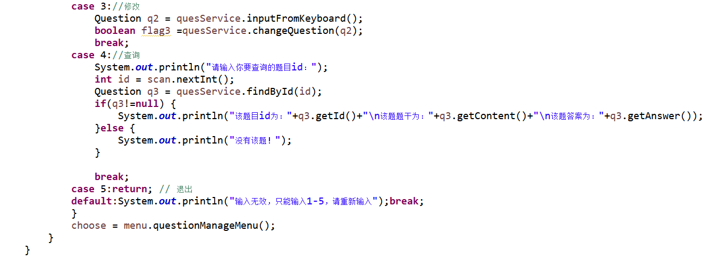

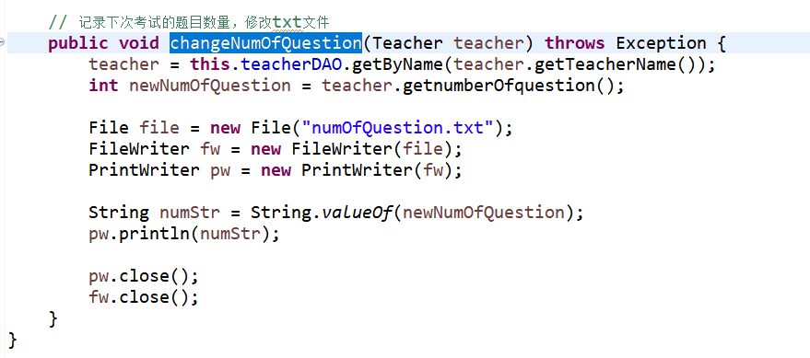

## **3.7.3 StudentService.java**

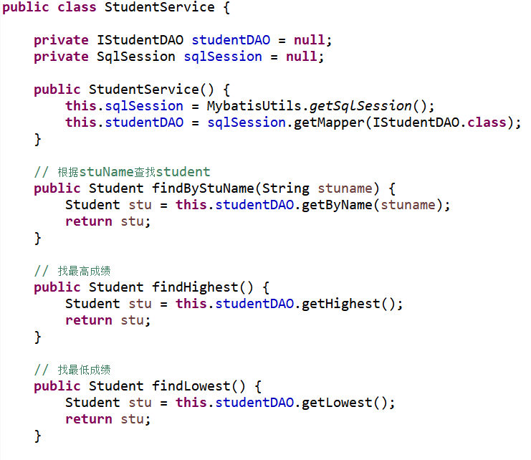

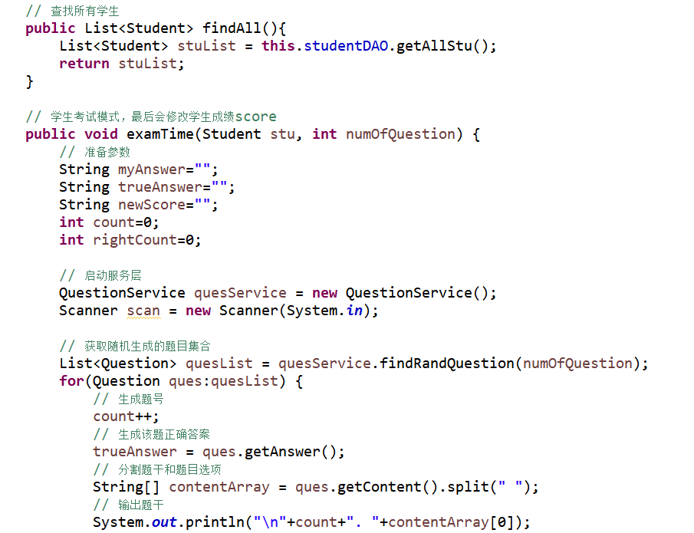

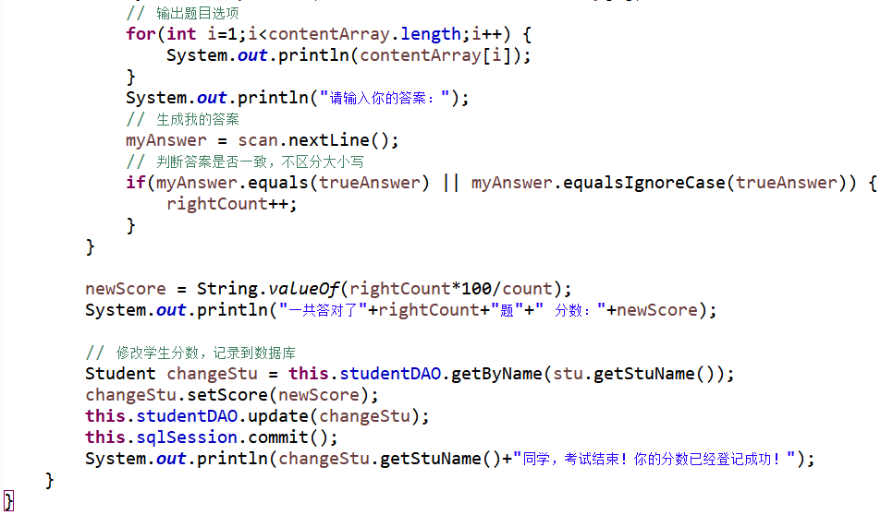

## **3.7.4 QuestionService.java**

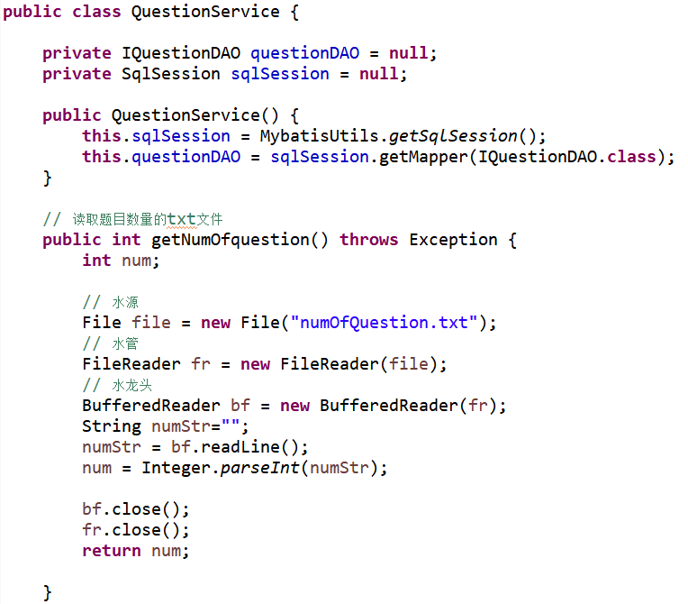

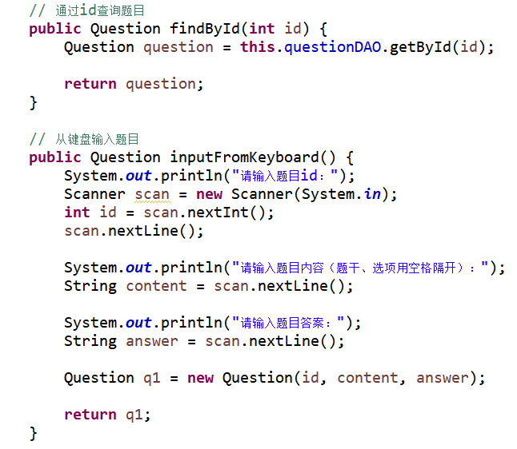

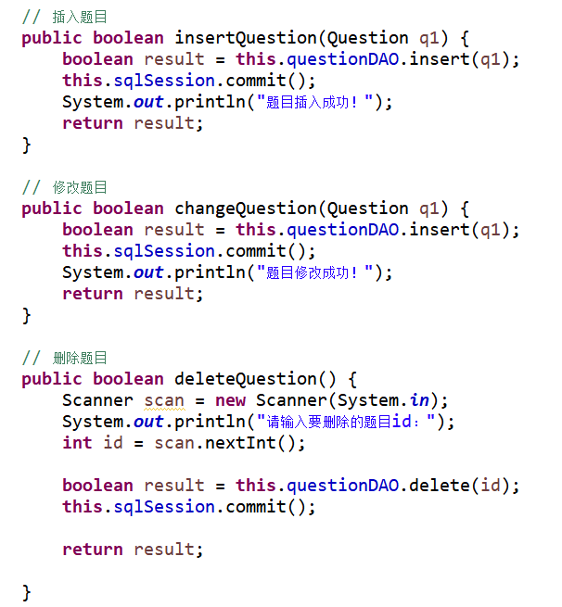

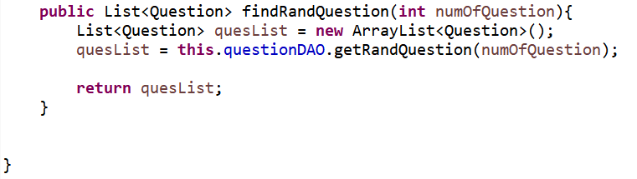

## 3.8 用户界面Driver.java

描述该文件作用，并对里面的关键代码进行解释

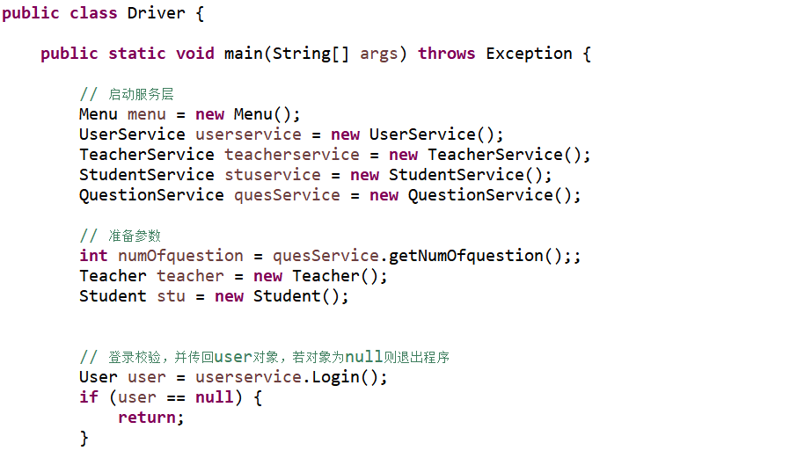

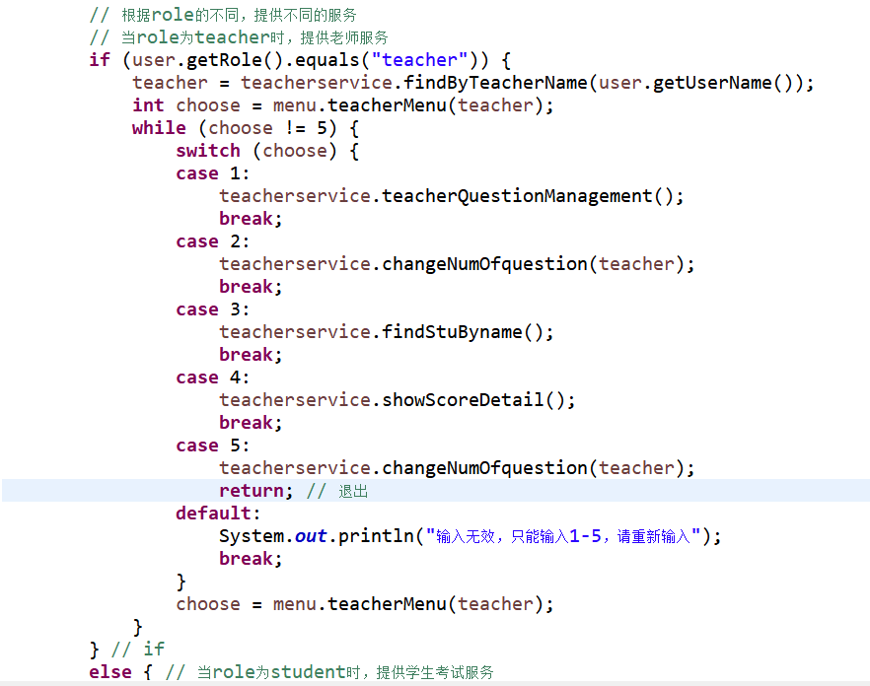

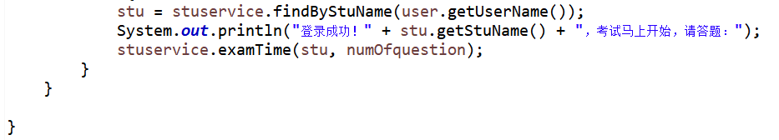

## 3.9 菜单Menu.java

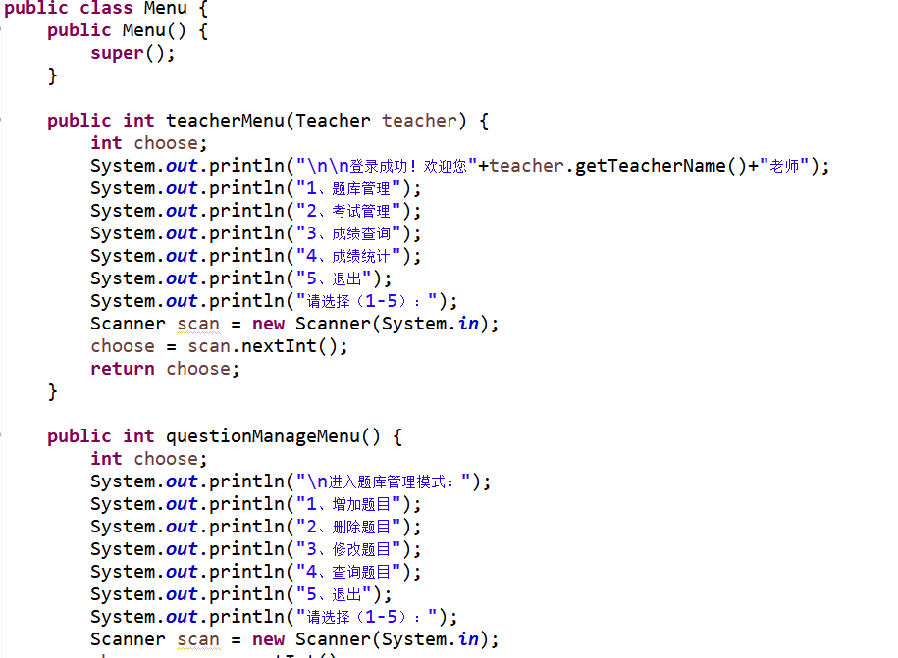

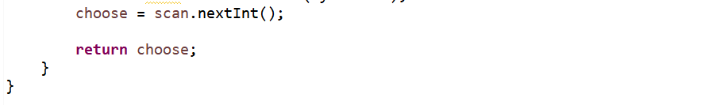

# **4 系统测试**

## **4.1 教师服务系统测试**

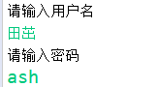

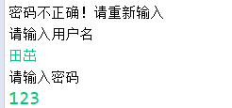



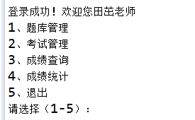

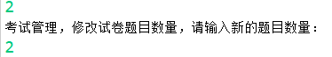

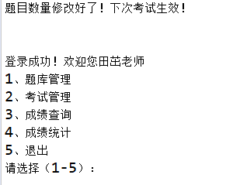

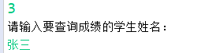



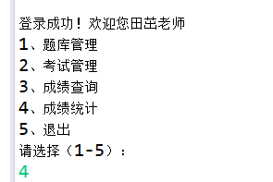

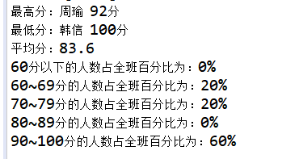

## **4.2 教师题库管理模式测试**

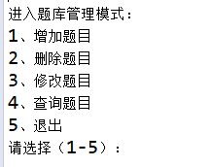

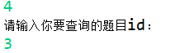

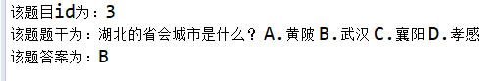

## **4.3 学生考试模式测试**







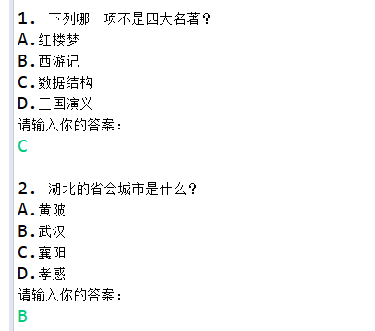

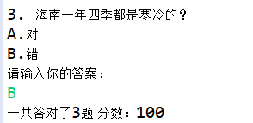



# **5 系统总结**

1. **在测试程序时报错：Executor was closed.**

**解决过程**：研究了半天发现，由于采用静态块模式全局只有一个sqlSession,当某一线程调用时即为独占此连接，之后调用完毕session.close()(不关闭连接肯定是不行的)时就把唯一的连接关闭了，而静态块只能在每次类加载时才会重新执行。

**解决办法**：改为公共的SqlSession工厂，所以线程可以从工厂获取和返还 连接。

1. **mybatis显示修改数据库成功, 但没有修改数据库的原因 (mybatis可以查询但无法修改数据库)**

**发现问题**：刚开始接触mybatis的时候, 遇到一个情况, 就是查询数据库没问题, 但是修改数据库(增删改)却会出错, 而且返回结果显示修改成功,实际却没成功。

**问题原因：**这个原因是因为mybatis默认不是自动提交事务的, 所以其实没有修改数据库,

刚刚新增完后立即返回的结果,是从mybatis为了提高性能设置的缓存里读取的,不是从数据库读取的

**解决办法**：**解决的办法一是在openSession() 的括号里写true, 设定自动提交事务；一是在代码中加入sqlSession.commit()**

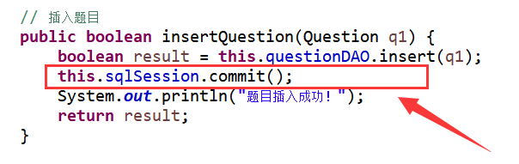

1. **在DAO层根据条件获取数据库元素的函数，在设置返回值的时如果设置为单个的vo实体对象，运行时会报错**

**问题原因：数据库中如果有多个对象满足条件时，返回对象只能有一个是不行的**

**解决办法**：**select类的函数返回值，尽量设置为List<类>的集合形式，这样既能应对单个对象又能处理多个对象。**

1. **通过本学期的java学习，学习到了很多课外内容，聂老师拓展的知识非常全面、非常实用。Mybatis是我掌握的第一个Java框架，老师教会我的不只是这一个框架，还有如何查阅文档学习框架的方法。通过每周长达近3h的网上授课，以及课下学习老师发的教案，在学习的过程中我们深刻感受到老师的用心。我发自内心的尊敬聂老师，我觉得我没理由不好好学习这门课。**
2. **以后的发展方向是考研究生，至于考什么学校还没想好，听说考研复试要看项目经验，剩下来的时间想跟着老师进行项目的实践。自评成绩80分，创新能力还有待提升。**